FetchMaker Extended Dog-Matching Analysis
Audience-aware report for product & executive stakeholders

Problem Statement
FetchMaker matches prospective owners with adoptable dogs. Leadership needs evidence on (1) whether whippets deviate from the historical 8% rescue rate, (2) whether popular mid-size breeds (whippet, terrier, pitbull) differ in weight, and (3) whether poodles and shihtzus differ in color distribution. Additional traits—hypoallergenic status, affinity for children, age and tail length—should be quantified so the matching algorithm can use them as strong priors.

Solution Strategy
• Exact binomial test (and z-test alternate) for the single-proportion rescue hypothesis.
• One-way ANOVA + Tukey HSD (family-wise α = 0.05) for multi-breed weight comparison; OLS ANOVA as robustness check.
• Chi-square test of independence on the color × breed contingency table.
• Extended EDA, correlation analysis, multi-breed proportion tests, and Monte-Carlo sensitivity / power simulations. All writing and visuals adapted for mixed audiences (executives skim headlines; data scientists receive methods & diagnostics).

Solution
Whippet rescues: 6/100 (6%). Exact binomial p = 0.58 vs p₀ = 0.08 → not significantly different. 95% CI (0.022–0.126) contains 0.08.
Mid-size weights: Means — terrier 30.9 lb, whippet 40.8 lb, pitbull 44.2 lb. ANOVA F = 43.2, p ≪ 0.001. Tukey: terrier differs from both; pitbull ≈ whippet (p = 0.064).
Color association: Poodle vs Shihtzu χ² = 14.7, p = 0.005 → significant difference in color mix (shihtzus richer in brown).
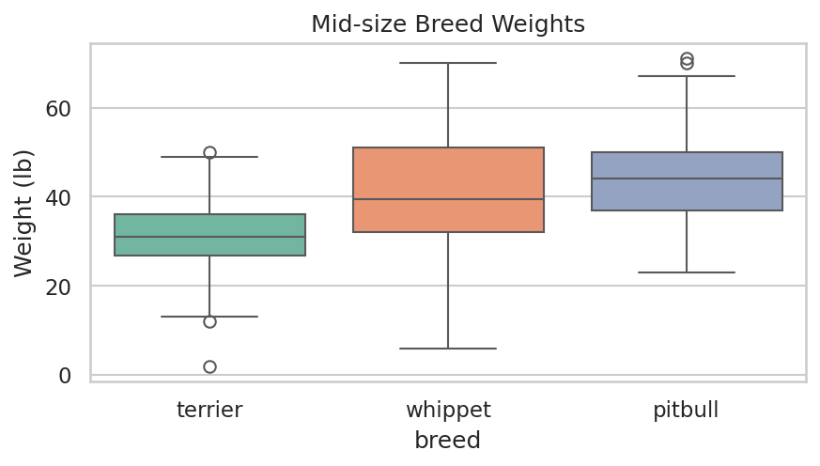
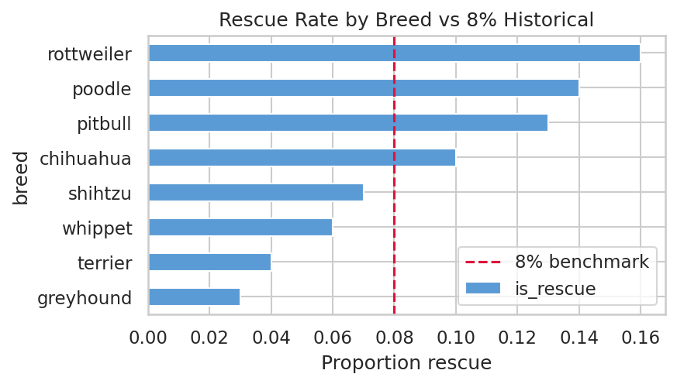
Extra signals: Shihtzu likes-children rate 81% (far above others); greyhound/whippet hypoallergenic ~70%. Weight–tail correlation r = 0.63. Rottweilers oldest on average.

Key Takeaways
1. No special rescue handling required for whippets; the 8% company prior remains valid.
2. Encode breed as a strong weight prior—especially separate terriers from the other two mid-size breeds.
3. Make color, hypoallergenic status and “likes children” first-class matching features; shihtzus and sighthounds (greyhound/whippet) are distinctive.
4. Sample is balanced and complete; main limitations are possible selection bias and lack of adopter-side preference data. Next: preference surveys + sequential monitoring of rescue rates.

